Object Oriented Programming Lab CSL-210

*Project Proposal on*

*“*Library Management System*”*

# Group Members:

|  |  |  |
| --- | --- | --- |
| 1. Emad Tariq | 02-134221-068 | BSCS-2B |
| 2. Soha Ather | 02-134221-088 | BSCS-2B |
| 3. Ammarah Ali | 02-134221-077 | BSCS-2B |

*Under The Supervision Of*

## Ms. Sameena Javaid (Course Teacher)

**Ms. Salas Akbar (Lab Engineer)**



Bahria University Karachi Campus (FALL 2022)

**Table of Contents**

# Pg. No

Chapter 1: Introduction 2

Chapter 2: Proposed System 2-3

Chapter 3: Diagrams

* 1. : UML Diagram 3
  2. : Flow Diagram 4

Chapter 4: Work Distribution 4

## CHAPTER 1: INTRODUCTION

The project titled "Library Management System" is a Library management software for monitoring and controlling the transactions in a library.

The project "Library Management System" is developed in java, which mainly focuses on basic operations in a library like adding new member, new books, and updating new information, searching books and members to borrow and return books.

"Library Management System" is a windows application designed to help users maintain and organize library. Our software is easy to use for both beginners and advanced users. It features a familiar and well thought-out, an attractive user interface.

The software Library Management System has four main modules.

1. Insertion to Database Module - User friendly input screen

2. Extracting from Database module - Attractive Output Screen

3. Report Generation module - borrowed book list & Available booklist

4. Search Facility system - search for books and members

## 

## CHAPTER 2: PROPOSED SYSTEM

The proposed library Management System deals with two separate classes users librarian respectively. Due to the proposed system the overall library experience will be revolutionized and this development will reduce the workload of the librarian, reduce the time used for carrying out operations and also increase efficiency by solving some of the difficulties encountered by people involved in this process. The first module is related to the librarian where he has ultimate control of the system. An Admin with his login Id and Login Password gets access to the system. By doing so he can conduct number of tasks such as viewBooks,updateinfo,search,viewCustomers.Hence he gets the charge of entering personal details and view account details of the account opener. Related to the management of Employees the Admin can change shift timings of Employee and can also apply increment to their salaries.The second Module deals with the user where he can view his books and current membership Status,books that are available to him , previous record of book . Moreover he has the access to update his personal information and login password.

.

## CHAPTER 3: DIAGRAMS

### : UML Diagram

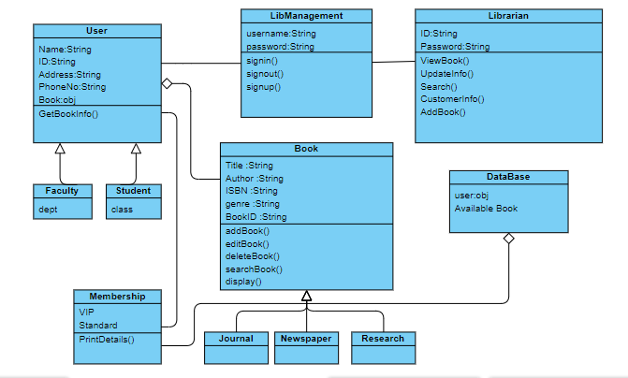

### : Flow Diagram

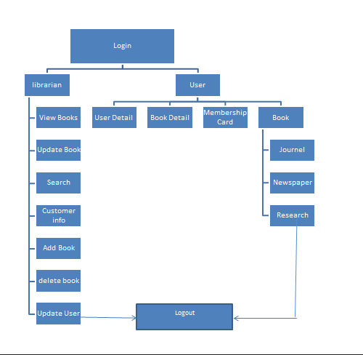

## CHAPTER 4: WORK DISTRIBUTION

### Emad Tariq

Creating and designing the artistic main theme of the project will be his task and constructing the librarian module will come under his responsibility while ensuring all major functions related to the respective module are produced. he will be responsible for the module's design and coding.

### Ammarah Ali

She will deal with the Book and membershipCard module will come under his responsibility while ensuring all major functions related to the respective module are produced.Designing and coding for this module will come under her domain.

### Soha Ather

Will be responsible for coding and designing of user module. She will be constructing forms and pages required for user class and all classes related to it where the respective functionalities could be carried out.